PROJECT DOCUMENTATION
Streamlining Ticket Assignment for Efficient Support Operations
Using ServiceNow Flow Designer and Automation

Skills: ServiceNow • Flow Designer • Access Control Lists • Role Management • Automation

Submitted by
GANESH B - F2B6E8DE190B69997BD45BE954C005D8
GOKILAN V - 53F9AD8184C2B70ACB54FED15DF0B3EC
GOKULAKRISHNAN S - DD5CBD4CB9D356294F7466E0D790DE5D
GOKUL R - 78ADBD5B6D3E40D96DC42398A514BBD0

ABSTRACT
This project focuses on improving support ticket management by implementing an automated ticket routing system in the ServiceNow platform. In modern organizations, support teams handle a large number of service requests and technical issues from users. Managing and assigning these tickets manually can lead to delays, incorrect routing, and inefficient use of resources.
To overcome these challenges, the project introduces an automated system that routes tickets to the appropriate support groups based on the issue type. The system is implemented using ServiceNow features such as Users, Groups, Roles, Custom Tables, Access Control Lists (ACL), and Flow Designer automation.
The project demonstrates how ServiceNow can be configured to automatically detect the type of issue submitted in a ticket and assign it to the correct support team. For example, issues related to certificates are assigned to the Certificates Support Group, while platform-related issues are automatically assigned to the Platform Support Group.
By automating the ticket routing process, the organization can significantly reduce response time, improve operational efficiency, and enhance customer satisfaction. The implementation also ensures better resource utilization and reduces manual workload for support staff.
The results confirm that automation within ServiceNow can streamline support operations, eliminate human errors, and provide a scalable solution for enterprise-level ticket management.

INTRODUCTION
Overview of ServiceNow Platform
ServiceNow is a cloud-based platform designed to automate business workflows and improve service management processes across organizations. It is widely used in IT Service Management (ITSM), Customer Service Management (CSM), and Human Resource Service Delivery (HRSD).
The platform operates on a relational database structure where all information is stored in tables. These tables store records such as users, incidents, service requests, and support tickets. ServiceNow also provides automation capabilities through tools like Flow Designer, Business Rules, and Access Control Lists.
Through automation and workflow management, ServiceNow helps organizations reduce manual work and improve efficiency.
Importance of Automated Ticket Assignment
In large organizations, thousands of support tickets are generated daily. These tickets may relate to system errors, login issues, certificate problems, or other technical requests.
If tickets are assigned manually, several issues may arise:
- Delays in ticket assignment
- Incorrect team handling the issue
- Increased workload for administrators
- Reduced customer satisfaction
Automated ticket routing solves these problems by automatically analyzing the issue type and assigning it to the correct support group.

Key Concepts Used in the Project
Users
Users represent individuals who interact with the system. These may include administrators, support engineers, or customers submitting tickets.
Groups
Groups are collections of users who handle similar types of tasks. In this project, groups are created for handling different types of support issues.
Roles
Roles define permissions and access rights within the ServiceNow system. They control which actions users can perform.
Access Control Lists (ACL)
ACLs provide security by defining which users or roles can access specific tables or records.
Flow Designer
Flow Designer is a low-code automation tool in ServiceNow used to create workflows that trigger actions automatically when certain conditions are met.

OBJECTIVES OF THE PROJECT
The main objectives of this project are:
- To automate the support ticket assignment process.
- To reduce manual intervention in ticket routing.
- To ensure tickets reach the appropriate support group quickly.
- To improve operational efficiency in the support department.
- To enhance customer satisfaction through faster issue resolution.
- To demonstrate workflow automation capabilities in ServiceNow.

TOOLS AND TECHNOLOGIES USED

Tool / Technology | Description
ServiceNow PDI | Personal Developer Instance used to build and test the project
Flow Designer | Used to automate ticket routing
Access Control Lists | Used to secure access to tables and records
Custom Tables | Used to store operations-related ticket information
Role Management | Controls user access to system functions

SYSTEM ARCHITECTURE / WORKFLOW
Ticket Submission → Operations Table → Flow Trigger → Condition Check → Assign Group → Ticket Resolution
Stage 1 – Ticket Creation
Users create support tickets describing the issue they are facing.
Stage 2 – Data Storage
The ticket details are stored in the Operations Related table.
Stage 3 – Flow Trigger
A Flow Designer trigger detects when a new ticket record is created or updated.
Stage 4 – Condition Evaluation
The system checks the issue type (for example login error or certificate issue).
Stage 5 – Automatic Assignment
Based on the issue type, the ticket is automatically assigned to the correct support group.

PROJECT IMPLEMENTATION STEPS
Milestone 1 – Creating Users
Users were created in ServiceNow to represent support staff members.
Steps involved:
- Navigate to System Security → Users
- Click New
- Enter user details
- Submit the form
Two users were created to handle platform and certificate support tasks.

Milestone 2 – Creating Groups
Groups were created to organize users based on their responsibilities.
Example groups:
- Certificates Support Group
- Platform Support Group
These groups handle different types of tickets.

Milestone 3 – Creating Roles
Roles were created to define user permissions.
Roles created include:
- Certificate Role
- Platform Role
These roles determine access rights within the system.

Milestone 4 – Creating Custom Table
A custom table called Operations Related was created to store ticket data.
Fields include:
- Issue Type
- Description
- Assigned Group
- Status
This table serves as the main repository for support tickets.

Milestone 5 – Assigning Users and Roles
Users and roles were assigned to the appropriate support groups.
Example:
Certificate Group
User: Katherine Pierce
Role: Certification Role
Platform Group
User: Manne Niranjan
Role: Platform Role

Milestone 6 – Assigning Roles to Table
Roles were applied to the operations table to ensure only authorized users can access the data.
Both platform and certificate roles were granted read and write permissions.

Milestone 7 – Creating Access Control Lists
ACL rules were created to secure access to the table fields.
These rules ensure that only users with appropriate roles can read or modify the records.

Milestone 8 – Flow Automation
Two automated flows were created.
Flow 1 – Certificate Issues
If the issue type is Regarding Certificates, the system automatically assigns the ticket to the Certificates Group.
Flow 2 – Platform Issues
If the issue type is:
- Unable to login to platform
- 404 error
- User account expired
The ticket is automatically assigned to the Platform Group.

RESULTS AND OUTPUT
The automated ticket routing system successfully assigns support tickets to the correct groups without manual intervention.
The system demonstrated the following outcomes:
- Tickets were assigned automatically based on issue type.
- Manual workload was significantly reduced.
- Ticket resolution time improved.
- Support teams received relevant tickets directly.
The automation improved overall efficiency in support operations.

ADVANTAGES
Automation of Ticket AssignmentSupport tickets are automatically routed to the correct teams.
Reduced Manual WorkAdministrators no longer need to manually assign tickets.
Improved EfficiencySupport teams receive issues related to their expertise.
Faster Issue ResolutionTickets are handled more quickly by appropriate teams.
Better Customer SatisfactionUsers receive faster responses to their issues.

LIMITATIONS
Limited Issue CategoriesThe system currently handles only a limited number of issue types.
Dependency on Accurate InputIncorrect issue selection by users may lead to incorrect routing.
Initial Configuration ComplexitySetting up roles, ACLs, and flows requires proper configuration knowledge.

SCREENSHOT

Activity 1:create a new user

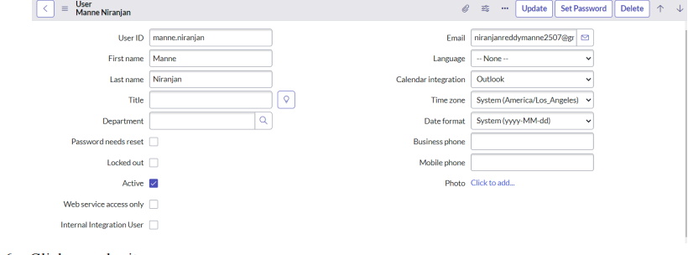

Activity 2:create a new group
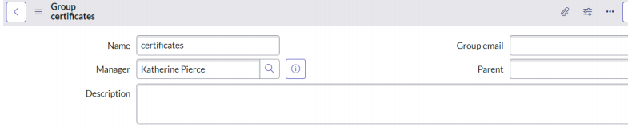

Activity 3:create a new role
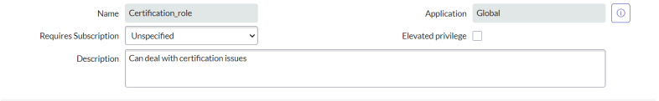

Activity 4:create a new ACL

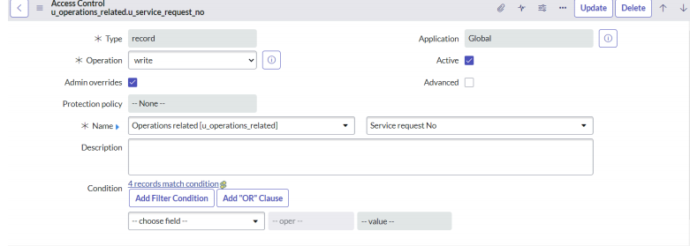

Activity 5:Create a Flow to Assign operations ticket to group

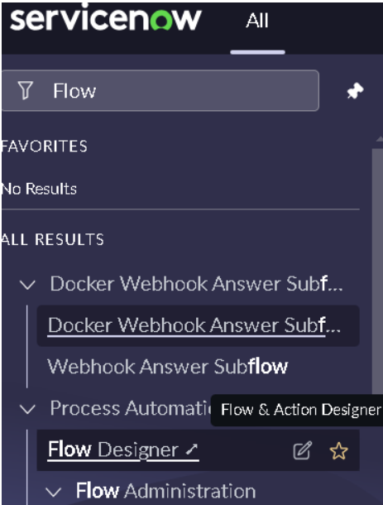
Activity 6:Flow Designer Click on new and select Flow

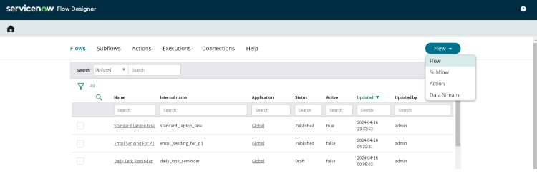

Activity 7:Regarding certificates and plartform

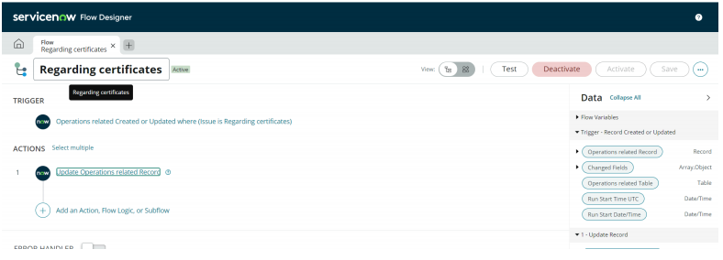

CONCLUSION
This project successfully implemented an automated ticket routing system using ServiceNow. By automating the assignment of support tickets based on issue type, the system eliminates manual routing errors and significantly improves operational efficiency.
The use of ServiceNow features such as Flow Designer, Access Control Lists, roles, and custom tables demonstrates the power of workflow automation in managing support operations. The solution ensures that tickets reach the correct support teams quickly, enabling faster issue resolution and improved customer satisfaction.
Overall, this project highlights the importance of automation in modern IT service management systems and provides a scalable framework for handling support tickets effectively.
FUTURE ENHANCEMENTS
Integration with AI-based ticket classificationAutomated priority assignment for critical issuesIntegration with external support systems
Dashboard reporting for ticket analyticsNotification alerts for ticket updates

REFERENCES
ServiceNow Documentation – Flow DesignerServiceNow Developer Portal
ServiceNow Platform Administration GuideIT Service Management Best Practices

